Assignment # 2 - Display Simple Object(Data) with JSX/REACT

Tasks to complete:

Note: Install Node and NPM before getting started with below steps, Node version should be greater than 12.

Install create-react-app
create-react-app is a tool to build React apps in no time. It allows us to create React apps without any build configuration.
- From your terminal, install create-react-app globally:
npm install -g create-react-app

2) Run below command in terminal/CMD
create-react-app my-app
cd my-app
npm start

Let's get started.

- Create a object in src/App.js as mentioned below:
const employee = {
name: 'Tom',
location: 'New York',
bloodGroup: 'B+',
age: 28,
profileImg: 'https://www.w3schools.com/howto/img_avatar.png'
}
- Display this data in the DOM and use classes to style the output as mentioned in below screenshot.
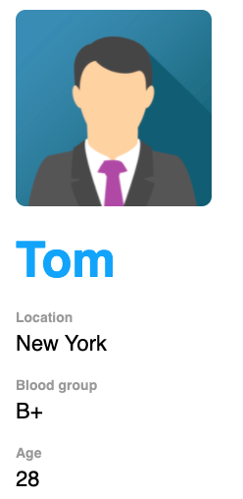

Submission Steps
- Please open your local repo and check if the repo contains “Assignment-2” folder. If it contains Assignment-2 please go directly to Step No.9. If it doesn’t contains please follow the below steps
- Open your local repo
- Make sure you are on master branch
- Make sure there are no pending changes (git diff HEAD will show all the pending changes)
- Run the following commands
- git remote add upstreamreactassignment_1 https://github.com/the-10x-academy/React-Assignments.git
- git pull upstreamreactassignment_1 (This will pull the latest assignments in to your local repo).
- git push origin main (This will update your repo on github with the changes pulled in the previous step).
- Please see the document in reactass-1/Assignment-2/doc.Please go to Assignment-2 folder in terminal and install react app. You can now start working on the Assignment-2
- git checkout -b "BranchName"
Note: Branch Name should be the Assignment Number for example : Assignment 1, command would be
git checkout -b Assignment-1

- Start making changes in index.html and style.css.
- Proceed with Staging using command git add . or use Vs code extension
- Git commit or use Vs code extension
- Git Push or use Vs code extension
- Create the Merge Request as mentioned in below screenshots.
  - Select the branch that checkout in step 4
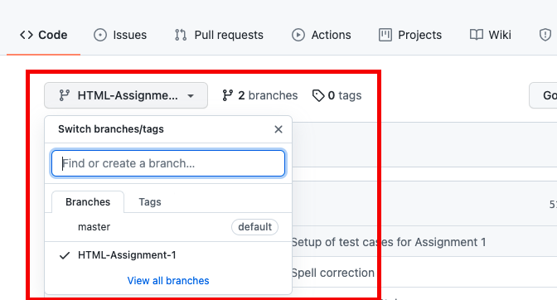

  - Click on “Pull request”
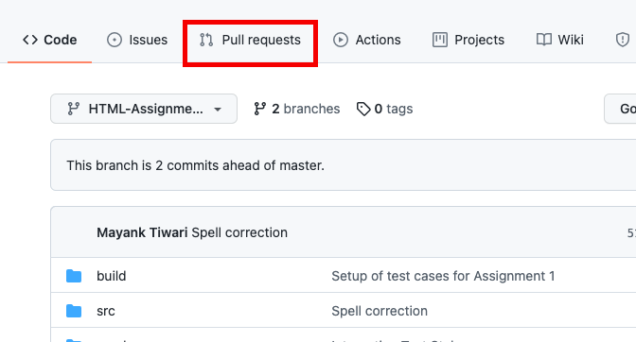
  - Click on “New Pull Request”
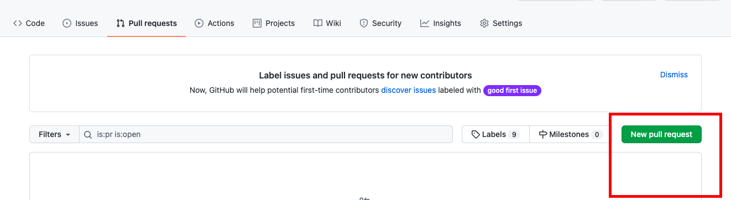

  - Select the branch that checkout in step 4
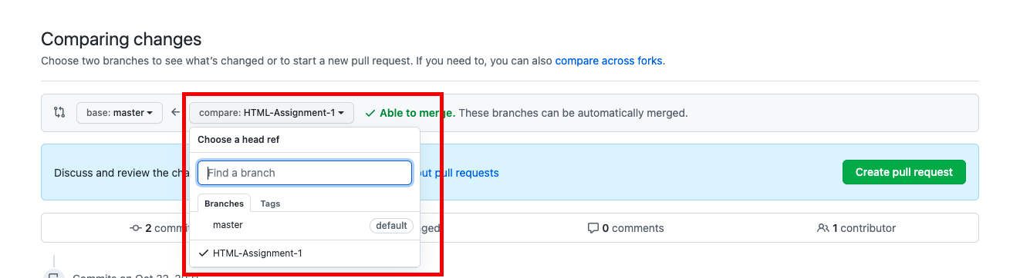
  - Create a pull request and share link of Request as your submission.
Please take screenshot of final output from your browser and keep in Pull Request description.
Share the Branch URL: https://github.com/{Username}/{Repo Name}/ pull/{Request Number}
